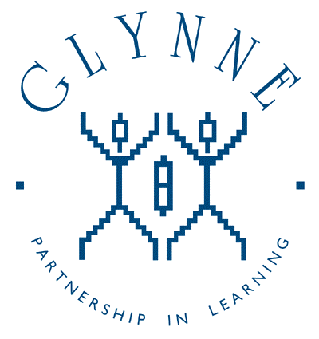

‘AIMING HIGH’

Code Of Conduct

At Glynne Primary School we believe it’s important to work in partnership with parents to support their child’s learning. We aim to do this by creating a safe, respectful and inclusive environment for all pupils, staff and parents, where all adults model appropriate behaviour for our pupils at all times.
As a partnership we are all aware of the importance of good working relationships and all recognise the importance of these relationships to equip our children with the necessary skills for their education. For these reasons we will continue to welcome and encourage parents and carers to participate fully in the life of our school.
The purpose of this code of conduct is to provide the expectations around the conduct of all parents, carers and visitors connected to our school.

This code aims to clarify the types of behaviour that will not be tolerated and seeks parental agreement to these expectations.

The code of conduct also sets out the actions the school can take should this code be ignored or where breaches occur.

We expect parents, carers and visitors to
- Respect the caring ethos of our school.
- Understand that both teachers and parents need to work together for the benefit of their children.
- Demonstrate that all members of the school community should be treated with respect and therefore set a good example in their own speech and behaviour.
- Seek to clarify a child’s version of events with the school’s view to bring about a peaceful solution to any issue.
- Approach the school in a supportive way to help resolve any issues of concern.

Behaviour that will not be tolerated:
- Disruptive behaviour which interferes or threatens to interfere with the operation of a classroom, an employee’s office, office area or any other area of the school grounds including team matches.
- Using loud or offensive language or displaying temper.
- Threatening in any way, a member of staff, visitor, fellow parent/carer or child.
- Damaging or destroying school property.
- Sending abusive or threatening emails or text/voicemail/phone messages or other written communications (including social media) to anyone within the school community.
- Defamatory, offensive or derogatory comments regarding the school or any of the pupils/parents/staff/governors at the school on social media platforms.
(Any concerns you may have about the school must be made through the appropriate channels by speaking to the class teacher, Senior Leaders, the Head teacher or the Chair of Governors, so they can be dealt with fairly, appropriately and effectively for all concerned)
- The use of physical, verbal or written aggression towards another adult or child. This includes physical punishment of your own child on school premises.
- Approaching someone else’s child in order to discuss or chastise them because of the actions of this child towards their own child. (Such an approach to a child may be seen to be an assault on that child and may have legal consequences)
- Smoking and consumption of alcohol or other drugs whilst on school premises.
- Dogs being brought on to the school premises, with the exception of guide dogs.

Should any of the above behaviour occur on school premises the school may feel it is necessary to refer to other relevant school policies and DfE guidance, contact the appropriate authorities and if necessary, even ban the offending adult from entering the school grounds.
Thank you for abiding by this code in our school. Together we create a positive and uplifting environment not only for the children but also all who work and visit our school.

What happens if someone ignores or breaks the code?

If the school suspects, or becomes aware, that a parent has breached the code of conduct, the school will gather information from those involved and speak to the parent about the incident. Depending on the nature of the incident, the school may then:

- Inform a parent/carer that they will not continue a conversation until the parent is measured and calm.
- Invite the parent into school to meet with a senior member of staff or the headteacher.
- Send a warning letter to the parent/carer.
- Contact the appropriate authorities (in cases of criminal behaviour)
- Seek advice from the local authority’s legal team regarding further action (in cases of conduct that may be libellous or slanderous)
- Ban the parent from the school site.
The school will always respond to an incident in a proportional way. The final decision for how to respond to breaches of the code of conduct rests with the headteacher.
The headteacher will consult the chair of governors before banning a parent from the school site.

Issues of conduct with the use of social media
Most people take part in online activities and social media. It’s fun, interesting and keeps us connected.
Within these spaces however we ask that you use common sense when discussing school life online.

‘Think before you post’ We ask that social media, whether public or private, should not be used to fuel campaigns and voice complaints against the school, school staff, parents or children.

We take very seriously inappropriate use of social media by a parent to publicly humiliate or criticise another parent, member of staff or child.

If parents have any concerns about their child in relation to the school as we have said above, they should:

- Initially contact the class teacher
- If the concern remains, they should contact Senior Leaders, or Headteacher.
- If still unresolved, the school governors through the complaint’s procedure

Parents and carers should not use social media as a medium to air any concerns or grievances.
Online activity which we consider inappropriate:
- Identifying or posting images/videos of children
- Abusive or personal comments about staff, governors, children or other parents.
- Posting defamatory or libellous comments
- Emails circulated or sent directly with abusive or personal comments about staff or children.
- Using social media to publicly challenge school policies or discuss issues about individual children or members of staff.
- Threatening behaviour, such as verbally intimidating staff, or using bad language.

At Glynne Primary school we take our safeguarding responsibilities seriously and will deal with any reported incidents appropriately in line with the actions outlined above.

